**SEA2004F Test – 26th April 2017**

**Answers all questions**

**Questions 1-10 (2 marks each), Questions 11-15 (5 marks each)**

1. What is the difference between accuracy and precision?

2. What properties of seawater determine its density?

3. What is salinity and why do we use a single chemical constituent (which one?) to determine it? What other physical property of seawater is used to determine salinity?

4. What are the significant differences between freezing pure water and freezing seawater? What happens to the salt in frozen seawater?

5. Fresh water has a density maximum at a temperature above the freezing point, which allows ice to float. Is this also true for sea water? Why does ice formed from sea water float?

6. Why is there a sound speed minimum in the middle of the water column? Give an example of a typical speed of sound profile through the ocean – include temperature and pressure profiles in your figure. What range of speed does sound travel in?

7. In a table explain the sequence of events leading to the expansion and eventual elimination of ocean basins.

8. Give 2 examples of a Lagrangian form of measurement. What oceanographic variables can be measured using these instruments?

9. With the aid of a diagram explain the main difference between a passive and an active continental margin?

10. List the atmospheric layers from the surface to the top of the atmosphere, and for each layer indicate whether temperature increases or decreases with altitude. Which layer of the atmosphere contains protective ozone?

­­­­­­­­­­­---------

11. Draw a diagram showing a sea-breeze circulation cell during the day. Indicate the direction the winds are flowing and areas of high and low pressure.

12. Changes in pressure with depth can be calculated using the hydrostatic equation

**P = ρgh**

Where:

P = pressure,

g = gravity = 9.8 m/sec2

h = height and

ρ = density kg/m3.

Using this equation show how the pressure in the water column increases at the following depths: surface (0m), 125 m and at 4300 m. Assume that gravity stays the same but that density changes and is the following 1025 kg/m3 at 0 m, 1026 kg/m3 at 125 m and 1028 kg/m3 at 4300 m.

13. Using the equation below show how the Ekman depth is influenced by both the latitude and wind strength for the following – wind speeds 5ms-1 and 25 ms-1 at latitudes 15°N and 60°S. Show schematically how this influences the Ekman spiral and overall net effect.

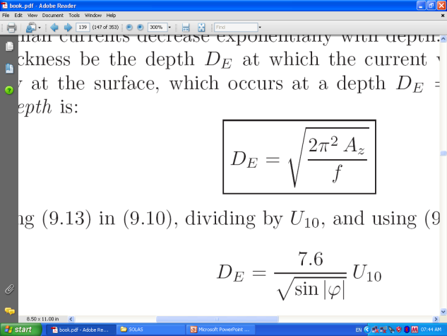

Where

DE is the Ekman depth in m

U is wind speed at 10 m above sea level (ms-1).

7.6 is a constant based on eddy viscosity.

14: Name two types of ocean circulation. Provide a table showing the forces that cause and retard these circulations.

15. Write out in full the meaning of CTD, XBT, ADCP, TSG. What surface velocities would you expect when collecting data across the Agulhas Current and the Benguela Current?

**-----------**

**STUDENT NUMBER _____________________________________________________**

**PLEASE HAND IN THIS PAGE**

**Multiple Choice – 1 mark each**

**1: The deep ocean province:**

A: Does not include the deep sea trenches.

B: Usually lies between the continental margins and the deep sea trenches.

C: Is usually bordered by the continental margin and the mid-oceanic province.

D: Contains transform faults.

**2: The area of the abyssal plains is gradually expanding as the abyssal hills are progressively buried by sediment.**

A: TRUE

B: FALSE

**3: Fracture zones are inactive parts of the transform faults and extend from the mid-oceanic province into the deep ocean province where they eventually vanish under the sediment.**

A: TRUE

B: FALSE

**4: According to the hypothesis of sea floor spreading:**

A: Sea floor splits open at the transform faults and new oceanic crust is added to the plate edge.

B: Transform faults are areas of tension.

C: Rift valleys split open and new rock is added in the center of the valley.

D: Rift valleys are areas of compression.

**5: Magnetic anomalies:**

A: Are locations on the Earth where there is no geomagnetic field.

B: Are always positive on the west side of the mid-oceanic ridge and negative on the east.

C: Result from the interaction of paleomagnetism and Earth's magnetic field.

D: Are produced by polarity reversals as volcanic rock is forming.

E: Are another name for polarity reversals.

**6: The Wilson cycle:**

A: Refers to the sequence of events from the creation of an ocean basin to its demise.

B: Is characterized by compression in the earlier stages and tension in the later stages.

C: Terminates when sea floor begins to be subducted into trenches.

D: Can be interrupted by the formation of hot spots.

**7: Negative magnetic anomalies result from the interaction of the geomagnetic field and rocks with paleomagnetism formed during a normal polarity.**

A: TRUE

B: FALSE

**8: The average sea floor spreading rate can be determined using the following formula: Average spreading rate = distance from crest of ridge/age of rocks.**

A: TRUE

B: FALSE

**9: Continents differ from sea floor in that:**

A: Continents are made of granite and sea floor is composed of basalt.

B: Continental rock is less dense than sea floor rock.

C: Continental rock is rich in aluminium and sea floor rock is rich in magnesium.

D: All of the above.

**10: Geostrophic flow:**

A: Is only significant in the gyres.

B: Is directly responsible for the formation of warm-water and cold-water rings.

C: Produces thermohaline circulation.

D: Results from a balance between Coriolis deflection and an opposing pressure gradient.

E: All of the above.